

**Revue d’Économie Régionale et Urbaine/**

**Journal of Regional and Urban Economics**

**Information for authors**

**Submission guidelines:** [**https://www.reru.fr/reru.php?categ=26&lg=EN**](https://www.reru.fr/reru.php?categ=26&lg=EN)

**Article Title (English)**

**Titre de l’article (French)**

First name Surname of the Author 1

Institution(s) of Author 1

[email.author1@adress.com](mailto:email.author1@adress.com)

ORCID iD (mandatory)

Corresponding author (corresponding author may not be author 1)

First name Surname of the Author 1

Institution(s) of Author 2

[email.author2@adress.com](mailto:email.author2@adress.com)

ORCID iD (mandatory)

Keywords

5 keywords maximum listed in alphabetical order: Keyword 1; keyword 2; …; keyword 5.

Mots-clés

5 mots-clés max listés par ordre alphabétique : Mot clé 1 ; mot clé 2 ; …mot clé 5.

**JEL Classification:** 1 to 5 codes

**Abstract**

Your abstract in English (between 250 words and 300 words in order to allow it to be referenced online).

**Résumé**

Votre résumé en français (entre 100 mots et 150 mots afin de permettre son référencement en ligne).

**highlights**

They consist of a short collection of highlights of the article (three to five of up to 120 characters (including spaces) each). They provide readers with an overview of the main findings. Think of them as an excerpt of the results.

*Example 1:*

* We examine the impact of density on aspects of social sustainability.
* Dense neighbourhoods are more likely to provide good access to services/facilities.
* Generally, social interactions are less in denser neighbourhoods.

*Example 2:*

* We test if workers from the "creative class" are likely to live in different parts of the city.
* The creative class is positively related to the percentage of gay households and income diversity.
* The creative class is negatively or not related to racial and linguistic diversity.

Article length: articles must be a **maximum of 50,000 characters including spaces and bibliography** but excluding abstracts and keywords.

**-1-**

**Introduction**

The body of the text is written in Times New Roman, font 12, single-spaced, with an indent of 0.5 cm and 6 pts spacing before and after each paragraph.

The title of the article is in Times New Roman, bold, font 20, and part titles are in font 16.

The introduction, parts and sub-parts are numbered.

Ideally, an article should have between 3 and 5 parts.

**-2-**

**Title of the first part**

(please avoid too long titles)

Each part should have a short introduction

**2.1. Citations and standards of presentation of the text.**

**2.1.1. References to literature:**

The authors mentioned in the text are mentioned without initials, like this: Author (2000) when they are directly cited in the text and like this (Author 1 and Author 2, 2000; Author et al., 2000) when they are cited in brackets after a development.

Acronyms are written in uppercase.

**2.1.2. Notes**

They must be treated as footnotes as follows[1].

**2.1.3. Abbreviations**

Give preference to developed forms over abbreviations of latin-anglicisms. For example, avoid *i.e.* , *e.g.*, *vs..*.

**2.1.4. Figures**

Put a non-breaking space between the number and the % character.

Use commas for decimals. Example: 10.52 and not 10.52

**2.1.5 Other guidelines**

For second rank citations use French quotation marks. For example: "citation « second rank citation » ".

Latin words and their abbreviations are in italics.

**2.2. Tables, Figures, Charts, Appendices**

Tables, illustrations and other figures are numbered consecutively and placed directly next to the current text referring to them and not at the end of the article.

For high-resolution off-text, please provide a separate high-resolution file, in addition to placing the low-resolution off-text in the article.

Tables, figures (including maps), sections and appendices are referred to in the body of the text as: (Table 1, Figure 1, Section 1, Appendix 1).

When they are mentioned in a sentence, they should be capitalized, for example, "Figure 4 indicates departments".

**2.2.1. Tables**

Tables should be inserted in the text and not collected at the end of the document. They should be in **text format** and not in image format. As a reminder, tables should not be counted in the count of the number of signs of the article.

Important information: tables must fit within a certain page size. Authors are strongly advised to avoid huge tables, otherwise the size will be significantly reduced and will lack legibility. 4 medium columns (or even 5 small ones) are much more readable than more columns. Similarly, long tables are necessarily cut off, which does not make them easier to read. In this case, it is recommended to make several small tables that segment the information .

The tables are numbered: 1, 2, 3 ...n. If they are in an appendix, their numbering is a continuation of the numbering of the article. For example, for an article whose last subject is Table 4, the first table in the appendix will be Table 5 and not Table 1A or A.

The data presented in the tables will be centred horizontally and vertically in the cells.

The sources cited in the tables should be written as follows:

Source: Authors, Eurostat data (if the authors of the article produced the graphs and figures).

Table example:

Table 1 Evolution of the social housing stock 1968-1999

|  |  |  |  |
| --- | --- | --- | --- |
| **Année** | **Nombre de logements sociaux (en millier)** | **Taux de croissance** | **Stock par habitant** |
| 1968 | 1 395 |  | 7.5 |
| 1975 | 2 239 | 60 % | 11.1 |
| 1982 | 2 724 | 22 % | 13.5 |
| 1990 | 3 093 | 14 % | 15.2 |
| 1999 | 3 454 | 12 % | 16.4 |

Source : Recensement du logement 1999. Seules les résidences principales des unités urbaines de plus de 10 000 habitants en 1990 sont prises en compte. La colonne stock par habitant indique la moyenne pondérée du nombre de logement social par habitant entre les 433 unités urbaines. Les stocks de logements sociaux en 1968 et 1975 sont estimés en utilisant les dates de construction.

**2.2.2. Graphs, maps, diagrams and other illustrations**

They must be made in grayscale, because the Revue d'Economie Régionale et Urbaine is not in colour.

The numbering rules in the article and in the appendix are identical to those in the tables.

Ensure that the elements included in these objects are clearly legible (font size, map legends, graphs in particular). We recommend that the objects be lightly loaded and that their size be compatible with the format of the mock-up.

They should be inserted in the body of the text as a Jpeg image with a minimum resolution of 300 dpi.

Do not create images through multiple placement of anchored objects, nor through image overlay.

Graph example:

Graph 3. Title

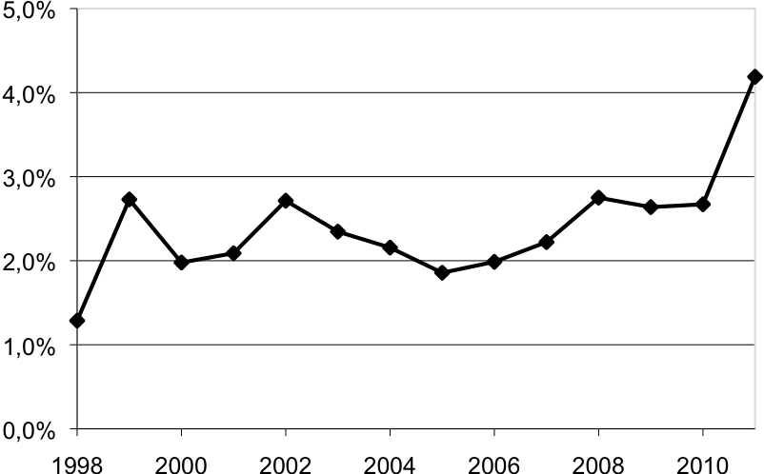

*Source : Trucy et Masseret Guene (2009), p. 126.*

**2.2.3. Equations**

The use of the equation field is strongly discouraged.

Preferred formats are, in order of preference:

1. MathType.

2. OMML from Word 2007 et later.

3. « Éditeur 3 »

The equations are numbered outside the equation software, in plain text like this:

|  |  |
| --- | --- |
|  | (1) |

# In the text explaining the meaning of the terms, they should be in italics. For example: where *w* designates ...

**-3-**

**Conclusion**

# Funding and Acknowledgements

Mention funding and any acknowledgements here

# Appendices

Appendices may include tables, figures and maps. See above for formatting and numbering instructions.

If there is more than one appendix, number them as follows: 1,2 …n.

**References**

**All references in the bibliography must correspond to references cited in the text, footnotes and appendices, and *vice versa*.**

**Authors must ensure that the names and dates cited in the text and in the bibliography correspond exactly to each other.**

**Authors' names must be in lower case with an uppercase initial, followed by the initial of the first name without an abbreviated period, followed by the date of publication in brackets.**

**References are treated in alphabetical order of authors, articles, books and mixed contributions, and should be presented as follows, depending on the type of publication.**

**For titles in English: do not capitalize each word except on the first one, or if necessary (if the title includes an expanded acronym for example...).**

**The elements of the collation are simplified and abbreviated as much as possible: the mention of translation (e.g. trad. fr.), the edition number (3rd ed.); the name of the publisher (PUF, MIT Press; Éd du Progrès); retain only one place of publication.**

**Delete redundant indications (e.g. delete the indication of the city "Cambridge", if it already appears in the publisher's mention "Cambridge University Press").**

**Collections: present as follows, for example: Edward Elgar (Research Literature Reviews in Economics).**

**Articles:**

English:

Stathakis D, Tsilimigkas G (2015) Measuring the compactness of European medium-sized cities by spatial metrics based on fused data sets. *International Journal of Image and Data Fusion* 6(1): 42–64.

French :

Blondel D (1967) Note sur le coût de régression. *Revue d’Économie Politique* 77 (1) : 59-95.

**Book:**

English:

Anselin L, Rey R (2014) *Modern spatial econometrics in practice. A guide to GeoDa, GeoDaSpace and PySAL*. GeoDa Press, Chicago.

French :

Combes P P, Mayer T, Thisse J F (2006) *Économie Géographique : l'intégration des régions et des nations*. Economica, Paris.

**Book chapter:**

English:

Stake R E (2003) Case study. *In*: Denzin K, Lincoln Y (eds) *Strategies of qualitative enquiry*. Sage Publications, Newbury Park: 236-247.

French :

Benko G, Bouinot J (2003) Compétitivité et promotion des villes moyennes en Europe. *In*: Charbonneau F, Lewis P, Manzagol C (dir.) *Villes moyennes et mondialisation, Renouvellement de l’analyse et des stratégies*. Éditions Trames, Montréal : 190-199.

**Reports, research papers, briefs:**

French and English:

Morry M (2018) *An equal exit? The distributional consequences of leaving the EU.* Briefing II, Institute for Public Policy Research.

**Presentation:**

English:

Marsden T K, Miele M, Morgan S L (2007) [Creating agricultural multifunctionality: ecological entrepreneurship and the eco-economy in comparative perspective](http://orca.cf.ac.uk/29342). RGS/IBG Annual Conference, London, 29-31 August.

French :

Lepicier D, Doré G, Diallo A (2012) Pays et intercommunalité, quelles perspectives de la réforme des collectivités territoriales pour les territoires de projets ? XLIXe Colloque de l’ASRDLF, Belfort, 9-11 juillet.

**PhD thesis:**

Bouzouina L (2008) *Spatial segregation and metropolitan dynamics*. PhD in economics, Université Lumière Lyon 2.

**Online documents:**

English:

Markusen J R (2002a) Integrating multinational firms into international economics. *NBER Reporter* [online] http://www.nber.org/reporter/winter02/markusen.html

French :

L’observatoire des territoires (2017) Dynamiques de population. Fiches d’analyse [en ligne] <http://www.observatoire-des-territoires.gouv.fr/observatoire-des-territoires/fr/dynamiques-de-population>

1. Footnote.