**Revue d’Économie Régionale et Urbaine/**

**Journal of Regional and Urban Economics**

**Instructions for authors**

**Submission guide:** [**https://www.reru.fr/reru.php?categ=26&lg=EN**](https://www.reru.fr/reru.php?categ=26&lg=EN)

**Title of the article in English**

**Title of the article in French**

First name Last Name of Author 1 (name in small capitals)

Author 1’s Institution(s)

[email.author1@domain.com](mailto:email.author1@domain.comourriel.auteur1@adresse.fr)

ORCID iD (mandatory)

Corresponding author (may be different from Author 1)

First name Last Name of Author 2

Author 2’s Institution(s)

[email.author2@domain.com](mailto:email.author2@domain.com)

ORCID iD (mandatory)

Keywords

Up to 5 keywords in alphabetical order: Keyword 1; Keyword 2; …; Keyword 5.

Mots-clés

5 keywords in French in alphabetical order: Mot clé 1 ; mot clé 2 ; …mot clé 5.

**JEL Classification :** 1 to 5 relevant codes

**Abstract**

Your abstract in English (between 250 and 300 words to allow for online indexing).

**Résumé**

Your abstract in French (between 100 and 150 words to allow for online indexing).

**Highlights (in English)**

A short list of three to five highlights of the article (each no longer than 120 characters including spaces). They give readers an overview of the main findings. Think of them as a snapshot of your results.

*Example 1:*

• We examine the impact of density on aspects of social sustainability.

• Dense neighborhoods are more likely to provide good access to services/facilities.

• Generally, social interactions are less frequent in denser neighborhoods.

*Example 2:*

• We test whether “creative class” workers tend to live in different urban neighborhoods.

• The creative class is positively related to the share of gay households and income diversity.

• The creative class is negatively or not related to racial and linguistic diversity.

**Points clés (in French)**

Using the same format as the highlights in English, they consist of a short collection of highlights from the article, three to five of up to 120 characters (including spaces) each.

**Article length**

Articles must not exceed **8,000 words**, including: references, figure and table captions, and endnotes.

**-1-**

**Introduction**

The body of the text is in Times New Roman, font 12, single-spaced, with a 0.5 cm indent and 6 pts spacing before and after each paragraph.

The title of the article is in Times New Roman, bold, font 20 and the part titles are in font 16.

The introduction, parts and sub-parts should be numbered.

Ideally, an article should have between 3 and 5 parts.

**-2-**

**Title of the first part**

(avoid too long titles)

Each part should have a short introduction.

**2.1. Citations and standards of text presentation.**

**2.1.1. Bibliographical citations:**

Authors mentioned in the text are mentioned without initials, as follows: Author (2000) when they are quoted directly in the text and like this (Author 1 and Author 2, 2000; Author et al., 2000) when they are quoted in brackets after an elaboration.

Acronyms are capitalised.

**2.1.2. Notes**

They should be treated as footnotes as follows[1].

**2.1.3. Abbreviations**

Avoid Latin-English expressions and use the expanded form: i.e. ‘for example’, and not *i.e.*, *e.g.*, ‘c.-à-d.’, ‘p. ex.’.

**2.1.4. Numbers**

Put a non-breaking space between the number and the % character.

Use commas for decimals. Example: 10.52 and not 10.52

Centuries are written in words: xixth, xxth century.

**2.1.5 Other Advice**

Capital letters are accented.

For quotations, the inverted commas used are the following: “example” except for second-rate quotations for which the following inverted commas are used: “citation ‘second rank citation’”.

Latin words and their abbreviations are in italics.

**2.2. Tables, Figures, Maps, Appendices**

Tables, illustrations and other figures are numbered consecutively and placed directly next to the current text that refers to them and not at the end of the article.

For out-texts requiring high resolution, please provide a separate high-resolution file, in addition to placing the low-resolution out-text in the article.

Tables, figures (including maps), sections and appendices are referred to in the body of the text as follows: (Table 1, Figure 1, Section 1, Appendix 1).

When they are mentioned in a sentence, they should be capitalised, for example: “Figure 4 shows the departments”.

**2.2.1. Tables**

Tables must be inserted into the text and not collected at the end of the document. They must be in **text format** and not in image format. As a reminder, tables should not be counted when calculating the number of characters in the article.

Important information: tables must fit within a certain amount of page space. Authors are strongly advised to avoid gigantic tables, otherwise the body will be significantly reduced, and the text will be illegible. 4 medium columns (or even 5 small ones) are much easier to read than more columns. Similarly, long tables are inevitably cut off, which makes them harder to read. In this case, it is advisable to create several small tables to segment the information.

Tables are numbered: 1, 2, 3 ...n. If they are in an appendix, their numbering continues that of the article. For example, for an article whose last subject is Table 4, the 1st table in the appendix will be Table 5 and not Table 1A or A.

The data presented in the tables should be centred horizontally and vertically in the cells.

Les données présentées dans les tableaux seront centrées horizontalement et verticalement dans les cellules.

The sources cited in the tables should be written as follows:

Source: Authors, Eurostat data (if the authors of the article produced the graphs and figures).

Table example:

Table 1 Change in social housing stock 1968-1999

|  |  |  |  |
| --- | --- | --- | --- |
| **Year** | **Number of social housing units (in thousands)** | **Growth rate** | **Stock per inhabitant** |
| 1968 | 1 395 |  | 7.5 |
| 1975 | 2 239 | 60 % | 11.1 |
| 1982 | 2 724 | 22 % | 13.5 |
| 1990 | 3 093 | 14 % | 15.2 |
| 1999 | 3 454 | 12 % | 16.4 |

Source: 1999 Housing Census. Only principal residences in urban units with more than 10,000 inhabitants in 1990 are taken into account. The stock per inhabitant column shows the weighted average number of social housing units per inhabitant across the 433 urban units. The stocks of social housing in 1968 and 1975 are estimated using the dates of construction.

**2.2.2. Figures, maps, schemes and other illustrations**

They are produced in shades of grey, as the Revue d'Économie Régionale et Urbaine/Journal of Regional & Urban Economics is not printed in colour.

The numbering rules in the article and in the appendix are identical to those for the tables.

It is advisable to ensure that the elements included in these objects are easy to read (size of font, map legends and graphs in particular). As a general rule, we recommend that you use objects that are not very heavy and that their size is compatible with the format of the layout.

They should be inserted into the body of the text as images in Jpeg format, with a minimum resolution of 300 dpi.

Do not create images by placing multiple anchored objects, or by superimposing images.

**Figure example**

Figure 3. Excess cost of Opex (actual expenditure compared with LFI budgets) (1998-2011)

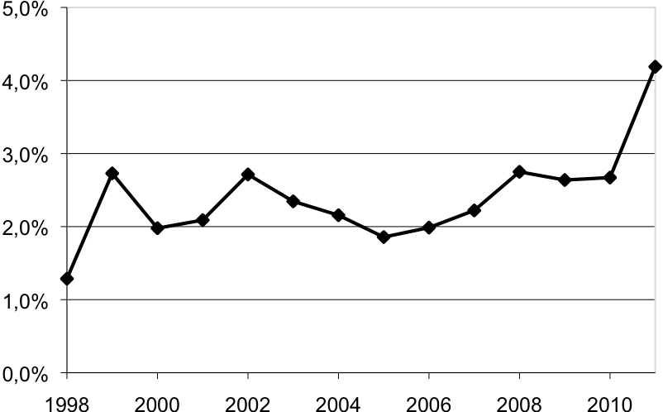

*Source : Trucy et Masseret Guene (2009), p. 126.*

**2.2.3. Equations**

Not recommended format: equation field.

The preferred formats are, in order of preference:

1. MathType.

2. OMML format in Word 2007 and later.

3. “Editor 3”

The equations are numbered outside the equation software, in plain text, as follows:

|  |  |
| --- | --- |
|  | (1) |

# In the text explaining the meaning of terms, they should be italicised. For example: with *w* meaning …

**-3-**

**Conclusion**

# Acknowledgements

Acknowledgements should be included here.

# Appendices

Appendices may include tables, figures and maps. See above for instructions on presentation and numbering.

If there are several appendices, number them as follows: 1,2 ...n.

**Bibliographical references**

All references in the bibliography must correspond to references cited in the text, footnotes and appendices, and vice versa.

Authors should ensure exact correspondence between names and dates referenced in the text and in the bibliography.

The journal adopts the **APA citation style (7th edition)**. Bibliographic references must be arranged in alphabetical order of author's name, without numbering, and must respect the punctuation specific to APA.

For each reference, indicate: author's surname(s) (first initial(s)), year of publication (in brackets), title of the book or article in italics depending on the type, title of the journal or publisher, volume and number (if applicable), and pages. For online resources, add the full URL link.

Collation elements should be simplified as much as possible, while respecting APA requirements. The place of publication should not be mentioned. The publisher should be mentioned in a concise but recognisable form (ex.: PUF, MIT Press, Éd. du Progrès). Do not repeat elements already present in the publisher's name (e.g. do not add "Cambridge" if the publisher is "Cambridge University Press"). Do not include collections unless they are essential for identifying the source.

Indicate the translation if the work has been translated (ex.: trad. fr. or translated by...). Give the edition number if it is not the first (ex.: 2nd ed.), placing it in brackets just after the title.

**Journal Articles:**

Blondel, D. (1967). Note sur le coût de régression. *Revue d’Économie Politique, 77*(1), 59–95.

Stathakis, D., & Tsilimigkas, G. (2015). Measuring the compactness of European medium-sized cities by spatial metrics based on fused data sets. *International Journal of Image and Data Fusion, 6*(1), 42–64.

**Books:**

Combes, P.-P., Mayer, T., & Thisse, J.-F. (2006). *Économie géographique : l'intégration des régions et des nations*. Economica.

Anselin, L., & Rey, R. (2014). *Modern spatial econometrics in practice: A guide to GeoDa, GeoDaSpace and PySAL*. GeoDa Press.

**Contribution to a collective work:**

Benko, G., & Bouinot, J. (2003). Compétitivité et promotion des villes moyennes en Europe. In F. Charbonneau, P. Lewis, & C. Manzagol (Dirs.), *Villes moyennes et mondialisation, renouvellement de l’analyse et des stratégies* (pp. 190–199). Éditions Trames.

Stake, R. E. (2003). Case study. In N. K. Denzin & Y. S. Lincoln (Eds.), *Strategies of qualitative enquiry* (pp. 236–247). Sage Publications.

**Reports, research documents, dissertations:**

Boiteux, M. (2001). *Transports : Choix des investissements et coût des nuisances*. Rapport du Commissariat Général au Plan. La Documentation Française.

**Communications:**

Lepicier, D., Doré, G., & Diallo, A. (2012, juillet 9–11). Pays et intercommunalité : quelles perspectives de la réforme des collectivités territoriales pour les territoires de projets ? Communication présentée au *XLIXe Colloque de l’ASRDLF*, Belfort, France.

Marsden, T. K., Miele, M., & Morgan, S. L. (2007, August 29–31). Creating agricultural multifunctionality: Ecological entrepreneurship and the eco-economy in comparative perspective. Paper presented at the *RGS/IBG Annual Conference*, London, UK.

**Thesis:**

Bouzouina, L. (2008). *Ségrégation spatiale et dynamiques métropolitaines* (Thèse de doctorat en sciences économiques). Université Lumière Lyon 2.

**Online Documents:**

L’observatoire des territoires. (2017). *Dynamiques de population. Fiches d’analyse*. <http://www.observatoire-des-territoires.gouv.fr/observatoire-des-territoires/fr/dynamiques-de-population>

Markusen, J. R. (2002a). *Integrating multinational firms into international economics*. NBER Reporter. <http://www.nber.org/reporter/winter02/markusen.html>

1. Footnote.